**Publishing of Research Paper in Journals**

The procedure to check the site for publication is mentioned below.

Few entities u all need to check, they are **Impact Factor, UGC approved, Reviews and the main is about the research papers published by the organization itself**.

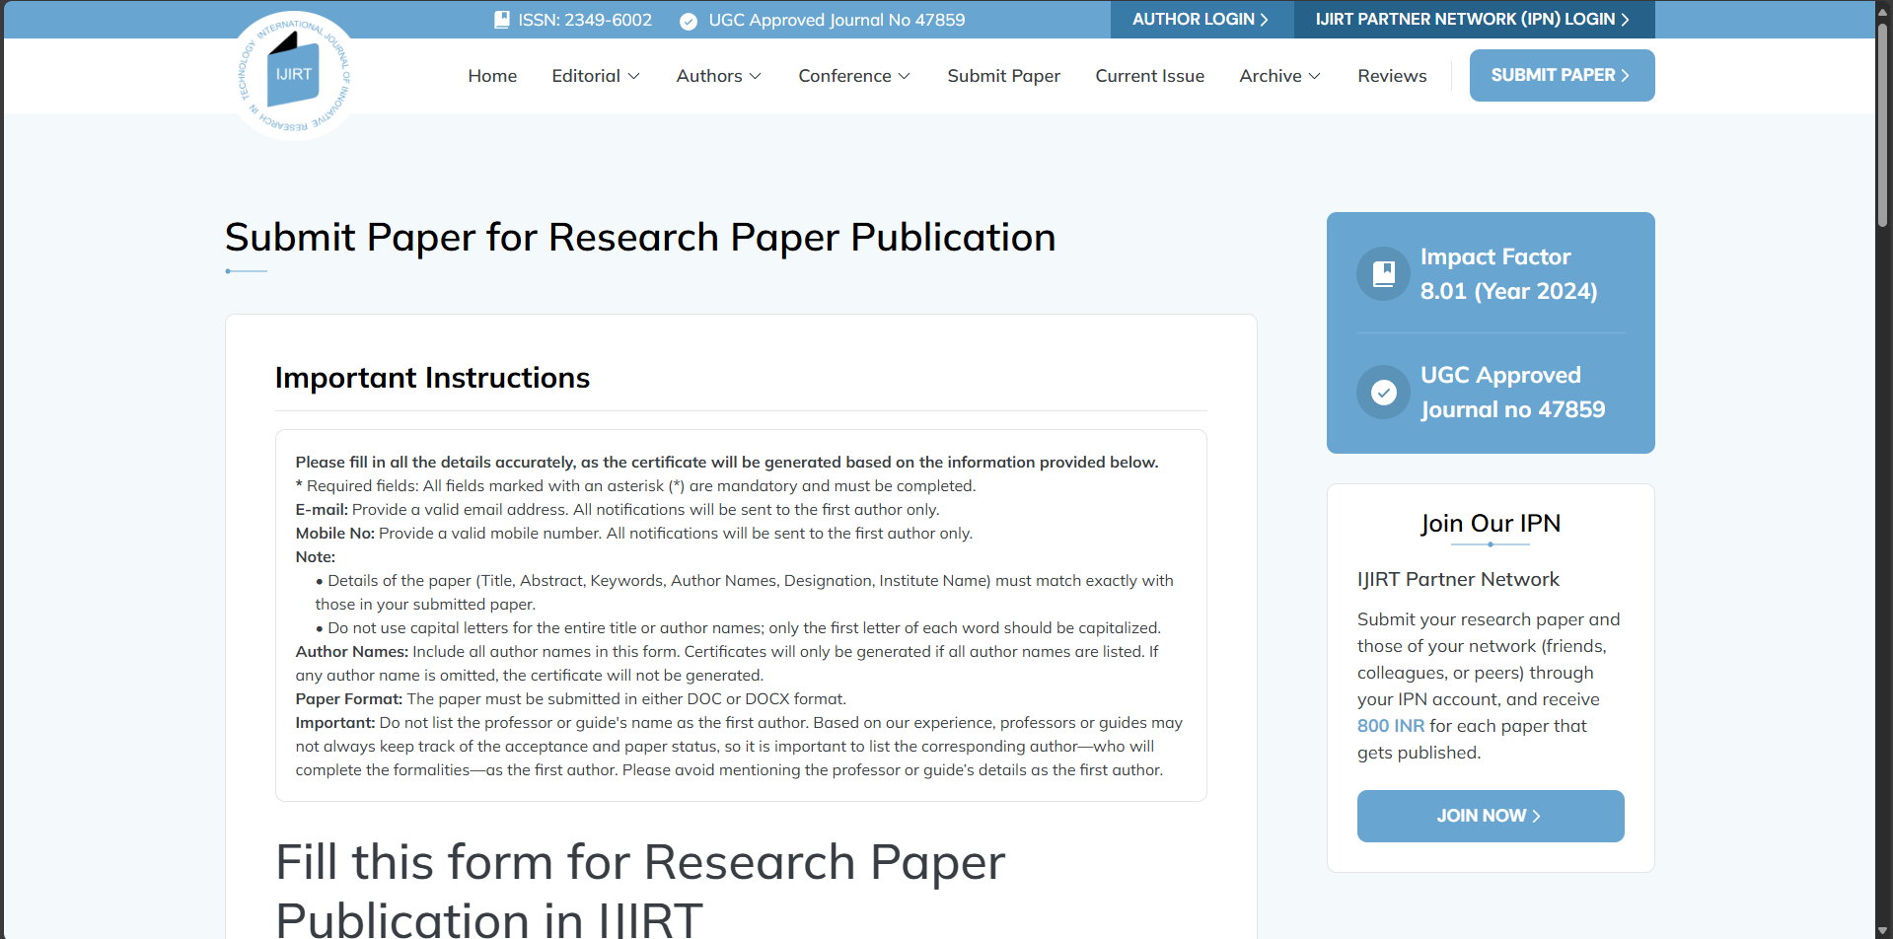Below is the Information of few Sites, Please Let me know, with whom Can we go for publishing !?  
**Deadline, Today 7.00 pm itself**  
  
1. <https://ijirt.org/>

2. <https://www.ijnrd.org/>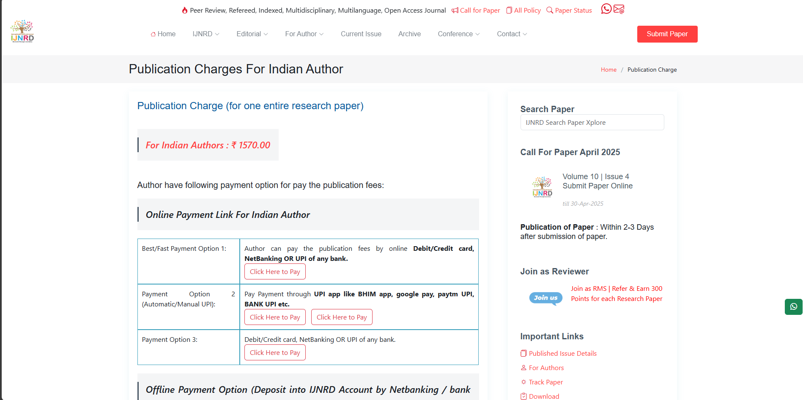

3. <https://www.ijfmr.com/>



4. https://www.ijsr.net/

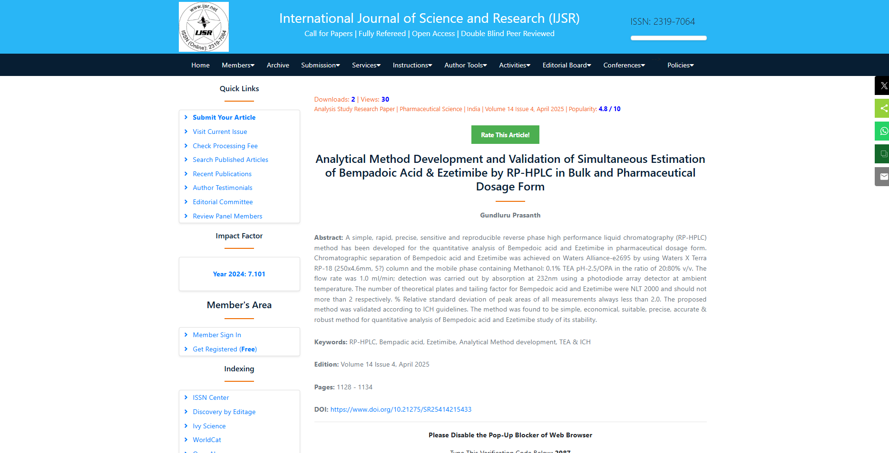

5. https://www.ijraset.com/  
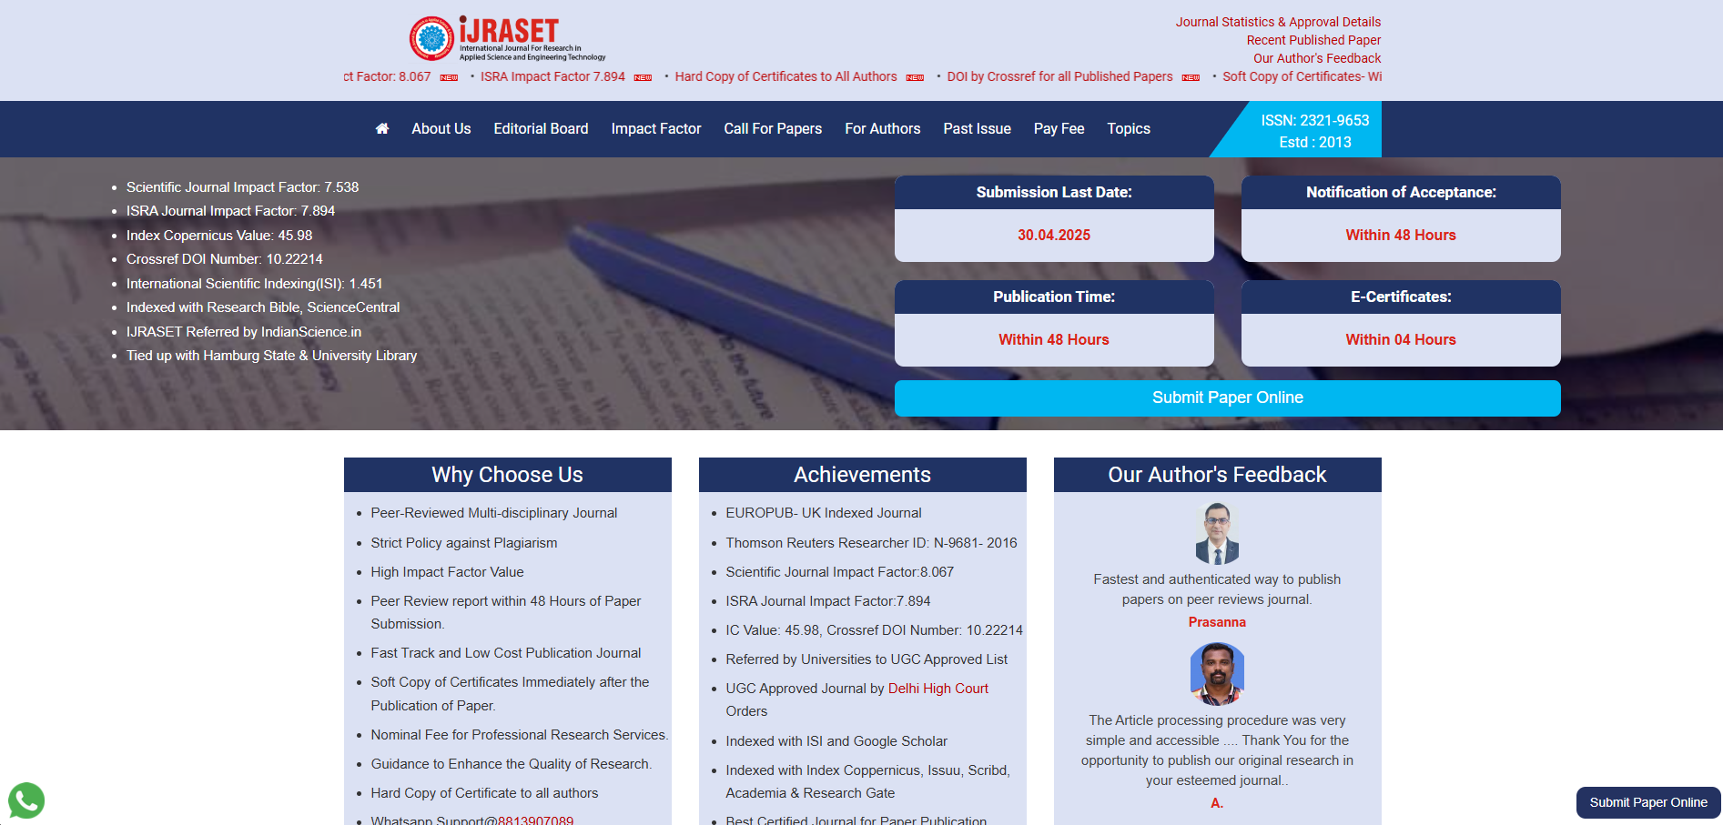

6. https://www.ijaresm.com/

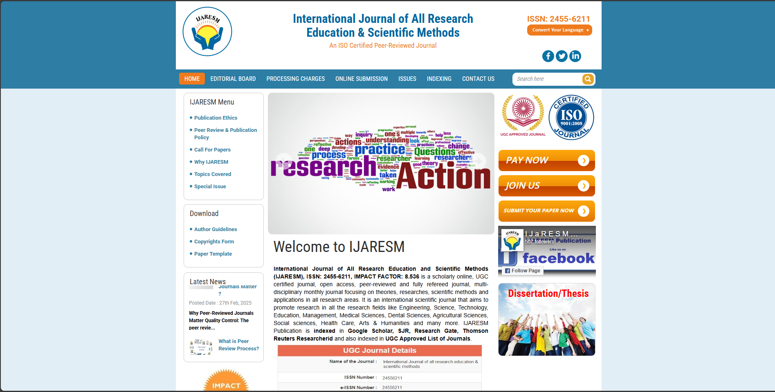

7. https://www.ijisrt.com/paper-publishing-sites



**Note**: Make sure, that we need to select one of them which has the best aspect in each and every factor. So, all are requested to make a documentary about which is best and compare it with each factor. After that Submit the given link. Which might be conveyed u later.